Q2

1. IGMPV3, TLSv1.2, TCP, HTTP, UDP, ARP, DB-LS
2. HTTP GET Sent at 2.058656, HTTP OK received at 2.602701, time taken is 0.544 ms probably.
3. My computers ipv4 address is 192.168.29.154, the websites ipv6 address is 2404:6800:4002:804::2004

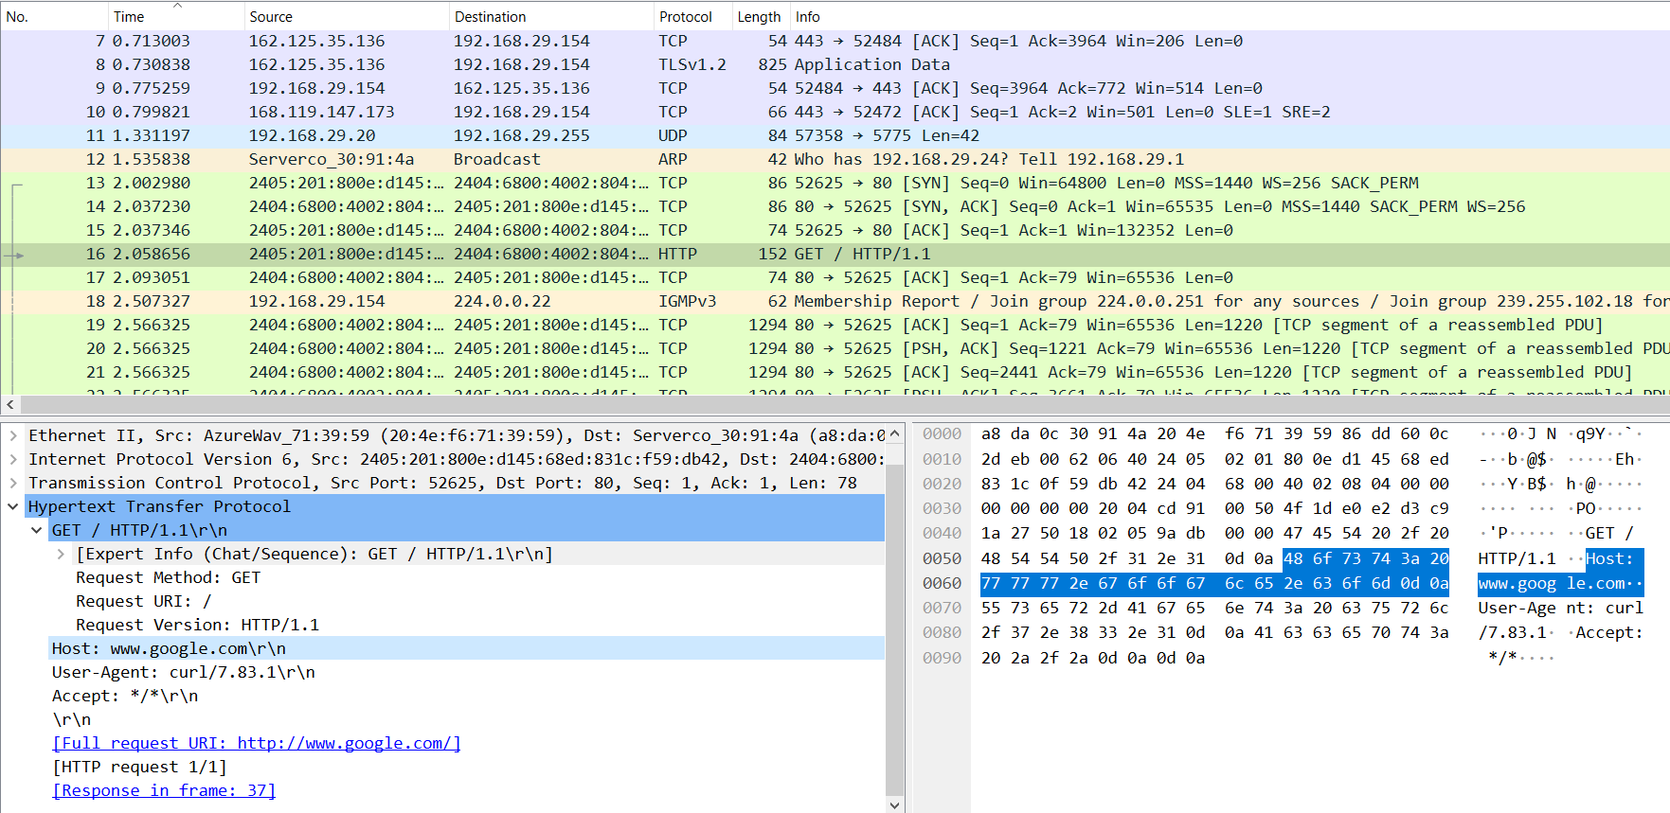

1. The host is [www.google.com](http://www.google.com)

3

The packet bytes are highlighted in the image

4

The first four bytes of host are 48 6f 73 74

5